Everything Enterprise Filters
Within search results, you can use filters to narrow down your results.

Across the top of the search results are icons of the different types of formats the library has, from Book to CD-Book to DVD to LargePrint items to Games. Clicking on these icons will narrow the search to include only results of that particular format.

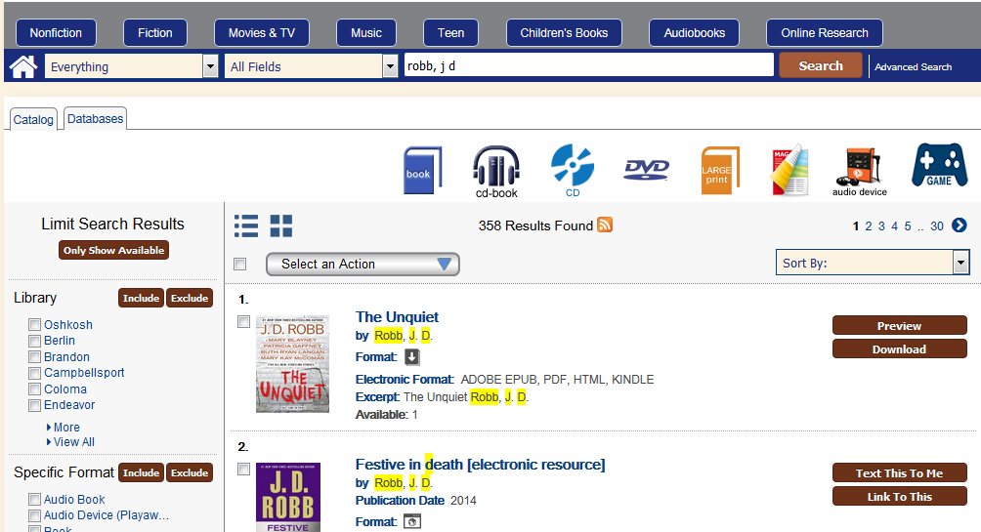

For example, clicking on the Book Icon has these results:

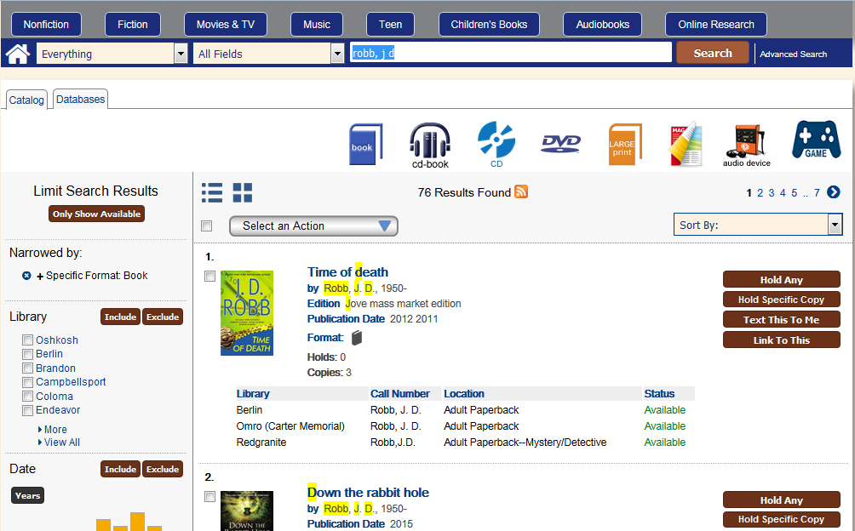
These same icons appear for all searches, even if there are not results for that specific format.

If you want to limit by more than one format, use the format facet on the left bar: check the boxes of the formats you want, and then click the “Include” button.
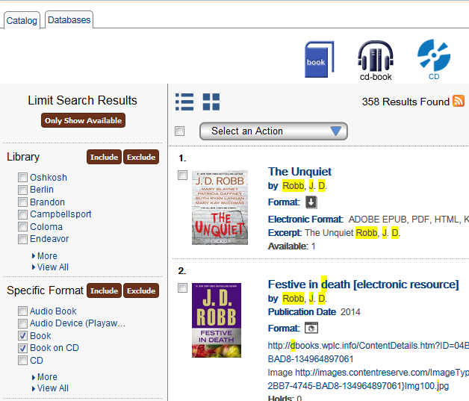

Notice that the formats selected appear on the left side bar under “Narrowed by:”
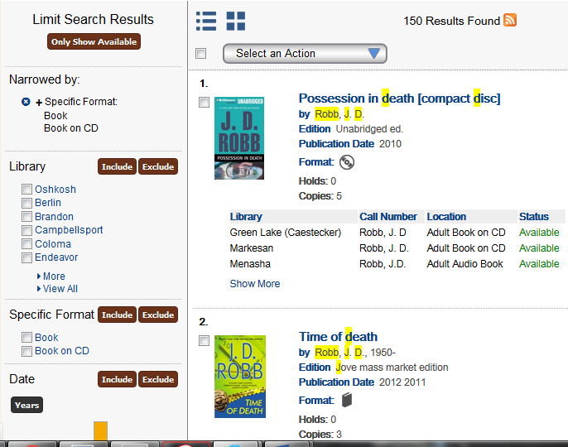

To see all facets, click the “More” or “View All” beneath the checkboxes:
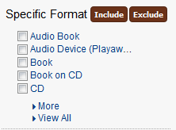

If you want to see everything except certain formats, you can check the facets for the unwanted formats and use the “Exclude” button.
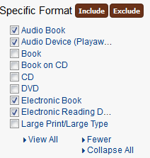
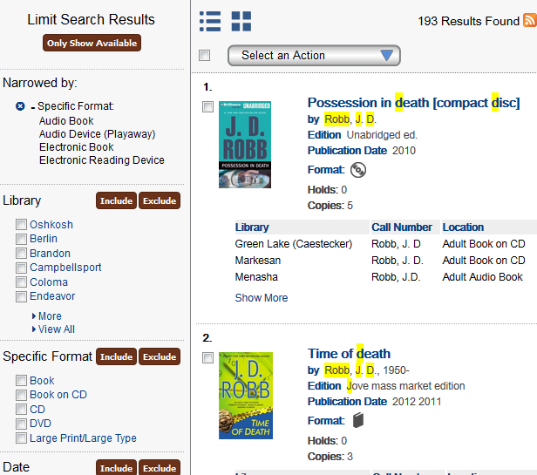
(Note the little dash to the left of the “Specific Format” header, indicating that these are results without these formats.)

To clear facets, click the blue circle with the white X to the left of the “Specific Format” header. The search will refresh to include all possible formats.

There are other facets along the left-hand bar that can optionally be used to further narrow a search. In order, they are:

Library: The library that owns the item. By default, the library selected from the catalog’s opening screen (“Profile library”) will appear on top. Using Oshkosh as an example:
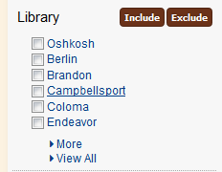
Specific Format:
As discussed above, this is the format the item is in, from Books to LargePrint Books to DVDs.

Date:
This is the date an item was published. This facet displays as a bar graph, with the most popular items having taller bar:
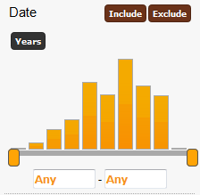
You can use the sliders to enter a range of dates, or key in years in the “Any” range box. You can also click the “Years” button to change the graph to a list of years to select:
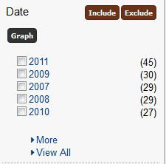

eMaterial:
This facet will limit search results to eBooks, eAudiobooks, or both.

Series:
This facet will limit search results to only items in a particular series, as defined in the item’s record.

Item Category:
This facet will limit search results to Fiction, Nonfiction, or Unknown (for example, Knitting Needles).

Age Group:
This facet will limit search results to Adult, YA-Teen, or Juvenile materials.

Electronic Format:
This facet will limit electronic materials to a particular format type (for example, limiting results to Kindle-compatible materials)

Language:
This format will limit search results to items in a particular language.

Author:
This format will limit search results to items by a particular author.

Subject:
This format will limit search results to items that have the particular subject heading, as defined in the item’s record.

Device:
This format will limit electronic materials to those compatible with a certain type of device (for example, Nook-compatible materials only).

Apart from facets, search results can also be sorted, most commonly to bring newest items to the top of the search results. On the top right of the search results is a “Sort by:” drop down box; click on the arrow of the drop down box:

Highlight and click on “Newest to Oldest”. The screen will refresh as the search results are sorted.

